**LAB SESSION 09**

**PREPARED BY MUHAMMAD FARAZ ANSAR**

* **JK-FLIP FLOP CIRCUIT:**

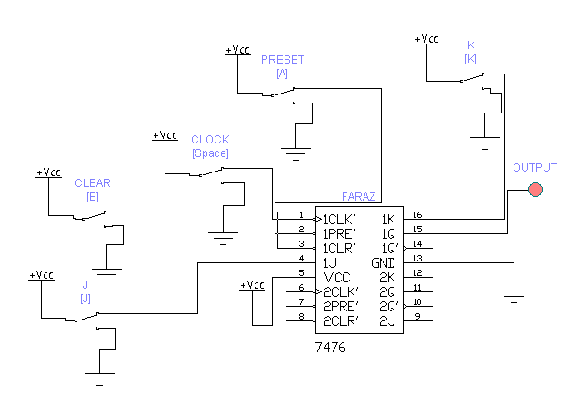

* **MOD-4 ASYCHRONOUS UP-COUNTER:**

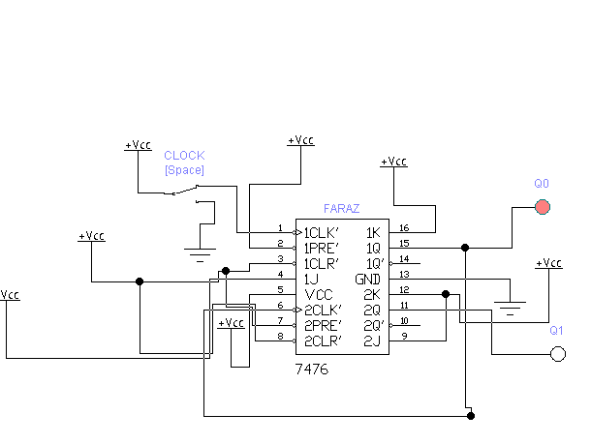

* **MOD-5 ASYCHRONOUS UP-COUNTER:**

